Concurrent Enrollment Partnership
Student Handbook
(Condensed email version)

High School Partnership Office
Iowa Western Community College
2700 College Road
Council Bluffs, IA 51503
F: (712)325-3708
highschooloutreach@iwcc.edu

Table of Contents
Introduction 4
Equal Opportunity and Non-Discrimination Statement 4
Welcome 5
Mission Statement 5
Campus Map 6
Contacts 7
Senior Year Plus Overview 7
Benefits of College Early Start 7
College Early Start Expectations 8
College Transcripts 8
Registration Process 9
REGISTRATION 9
ADDING A COURSE 9
DROPPING A COURSE 9
Academic Calendar 10
Parking Permit 11
Safety and Security 12
Reiver Alert System 12
Standard Response Protocol 13
Academics 14
COURSE SYLLABUS 14
ATTENDANCE 14
FINAL EXAMINATIONS 14
ACADEMIC STANDARDS 15
PROBLEM RESOLUTION 15
GRIEVANCE PROCESS FOR STUDENTS 15
Code of Conduct 16
IWCC Resources 17
ACADEMIC SUPPORT CENTER / TUTORING 17
COUNSELING/PERSONAL ADVISING 17
DISABILITY SERVICES 17
Iowa Western Policies 18
CAMPUS SECURITY AND LAW ENFORCEMENT 18
GENERAL PROCEDURES FOR REPORTING A CRIME OR EMERGENCY 18
TIMELY WARNINGS 18
CAMPUS EMERGENCIES 18
EVACUATION PROCEDURES FOR STUDENTS WITH DISABILITIES 19
VIDEO SURVEILLANCE 19
MONITORING AND ACCESSING VIDEO SURVEILLANCE RECORDINGS 19
RELEASE OF VIDEO SURVEILLANCE RECORDINGS 19
SECURITY AND RETENTION OF VIDEO SURVEILLANCE RECORDINGS 20
CIVIL RIGHTS ACT 20
EQUAL OPPORTUNITY AND NON-DISCRIMINATION POLICY 20
TITLE IX 20
PREGNANT AND PARENTING STUDENT STATEMENT 20
AMERICANS WITH DISABILITIES ACT AND THE REHABILITATION ACT 21
FERPA Information 21

Introduction
The information contained in this handbook is correct as of February 10, 2022, and is subject to cancellation or change without notice. This handbook cannot be considered as an agreement or contract between individual students and Iowa Western Community College, its faculty, staff, administrators, or directors.

Equal Opportunity and Non-Discrimination Statement
It is the policy of Iowa Western Community College to provide equal educational opportunities and not to discriminate on the basis of race, color, creed, religion, national or ethnic origin, ancestry, genetic information, physical or mental disability, age, sex, sexual orientation, gender identity or expression, pregnancy, marital status, veteran status, AIDS/HIV status, citizenship, or medical condition, as those terms are defined under applicable laws, in its educational programs, activities, or employment practices, as required by Iowa Code sections 216.6 and 216.9, Titles VI and VII of the Civil Rights Act of 1964 (42 U.S.C. § 2000d and 2000e), the Equal Pay Act of 1973 (29 U.S.C. § 206, et seq.), Title IX (Educational Amendments, 20 U.S.C.§§ 1681 – 1688), Section 504 (Rehabilitation Act of 1973, 29 U.S.C. § 794), and the Americans with Disabilities Act (42 U.S.C. § 12101, et seq.).

The following individuals have been designated to handle inquiries and complaints regarding equal opportunity and nondiscrimination:

EQUAL EMPLOYMENT OPPORTUNITY AND TITLE IX
Robyn Porter
Director of Human Resources/Title IX and Equal Opportunity Coordinator for Employees
2700 College Road
Council Bluffs, IA 51503
(712) 325-3413
rporter@iwcc.edu

DISABILITY DISCRIMINATION
Samantha Larson
Dean of Academic Support/ADA Coordinator for Students with Disabilities
2700 College Road
Council Bluffs, IA 51503
(712) 325-3341
slarson@@iwcc.edu

TITLE IX and OTHER FORMS OF DISCRIMINATION
Reanna Heim
Dean of Student Life/Title IX and Equal Opportunity Coordinator for Students
2700 College Road
Council Bluffs, IA 51503
(712) 325-3207
rheim@iwcc.edu
Inquiries and complaints may also be directed to the Director of the Office for Civil Rights U.S. Department of Education, John C. Kluczynski Federal Building, 230 S. Dearborn Street, 37th Floor, Chicago, IL 60604-7204, Telephone: (312) 730-1560 Facsimile: (312) 730-1576, TDD 800-877-8339 Email: OCR.Chicago@ed.gov.

Welcome
We are pleased you have selected Iowa Western Community College to begin your college education. We have a long-standing tradition of providing quality learning experiences throughout southwest Iowa, and we are dedicated to providing you with a valuable education. All of us at IWCC are committed to challenging our students to achieve their best in a caring, nurturing environment. We believe we are here to help you excel in meeting your higher education needs.
We encourage you to enhance your learning experience by utilizing the many services and participating in the activities offered by IWCC. You will find that participation outside the classroom provides opportunities for additional learning and for building support networks.
This student handbook is designed to answer most of your questions. However, if you have additional questions or need clarification on any subject pertaining to your enrollment at IWCC, please ask any staff member for assistance.
Iowa Western has many opportunities available to serve the diverse interest of our students, while small enough to care about your personal success.

Dr. Dan Kinney
President

MISSION STATEMENT
Iowa Western Community College is a learning college committed to excellence
in meeting educational needs and improving the quality of life through programs,
and partnerships and community development.

Campus Map

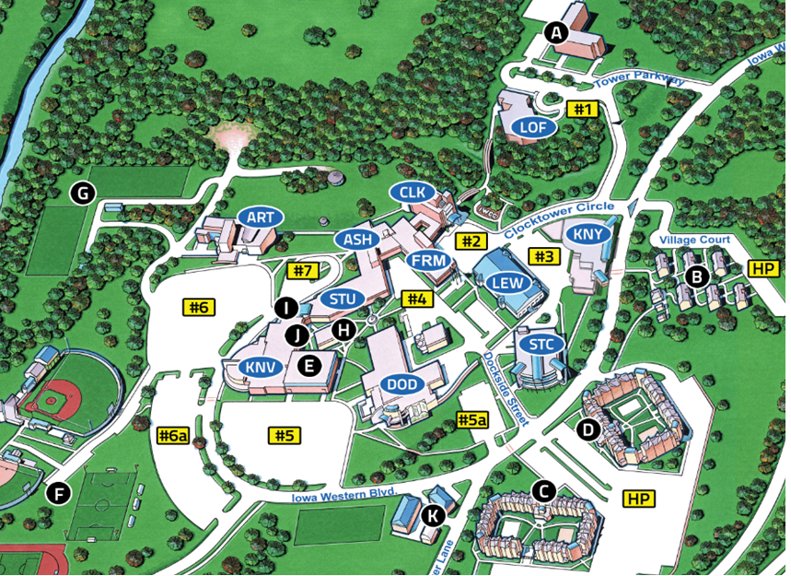

BUILDINGS
ART– Arts Center
ASH– Ashley Hall
CLK– Clark Hall
DOD– Dodge Hall
FRM– Fremont Hall
KNV– Kanesville
KNY– Kinney Hall
LEW– Lewis Hall
LOF– Looft Hall
STU– Stuart Hall
STC– Student Center

FACILITIES
A. Tower
B. Village
C. Suites I
D. Suites 2
E. Kanesville Gym & Arena
F. Athletic Fields
G. Foot
ball Practice Fields
H. Hoover Hall
I. KIWR 89.7 The River
J. CBTV 17

Parking Lots
#1 Visitor Parking
#2 Visitor Parking
#3 Commuter Parking
#4 Employee Reserved Parking
#5-5a Commuter Parking
#6-6a Commuter Parking
#7 Visitor Parking
HP-Housing Parking

Contacts
Dean of High School Partnerships: |  | 712.325.3288
Clarinda Center: |  | 712.542.5117
Cass County Center: |  | 712.243.5527
Page/Fremont Center: |  | 712.246.1499
Shelby County Center: |  | 712.755.3568
Books/College Store: |  | 712.325.3231
Security: |  | 402.659.4939
Registrar: |  | 712.325.3273

Senior Year Plus Overview
- Students enrolled in public and private high schools have available to them the opportunity to earn college credit and advanced placement while enrolled in high school.
- Promotes exploration of career and technical fields through classroom instruction and hands-on experiences
- IWCC has partnered with 35 local school districts to offer programs from which their students may select for enrollment. Students work with their school counselor to select the courses and enroll.
- Iowa resident students in grades 9 through 12 are eligible.

Benefits of College Early Start
- High Schools pay a designated college tuition rate on behalf of the student
- Students are responsible for minimal expenses
- Students find ease of transition from High School to College more attainable
- Students have the ability to explore career options
- Students have the opportunity to explore a variety of classes
- Students have advanced standing when enrolling as a degree-seeking full-time student.

College Early Start Expectations
- Students are expected to be in class regardless of the high school calendar and activities.
- Students will be treated as a college student. Professors are only made aware of grade standing through self –identification.
- Students are expected to use and adhere to the course syllabus provided by instructors.
- Counselors will be notified of student progress five times throughout the semester and of final grades. Students can access current grades in ROC at any time.

College Transcripts
By enrolling in College Early Start classes, this begins your official college transcript. Your college transcript(s) will follow you for the entirety of your academic career. Transcripts are a record of classes taken, grades received, credits earned and your cumulative GPA. Keep in mind the following:
- Good grades follow you, so do not-so-good grades.
- Better grades, better GPA will help secure future financial aid and scholarships.
- Poor grades, low GPA will impact eligibility for financial aid and scholarships.
- Poor grades, low GPA will impact eligibility for high school AND college athletics.

In order to be successful and maintain eligibility, it is very important you work with and talk to your Instructors. Iowa Western Community College offers many resources to help you succeed.
Academic Support - Iowa Western Community College (iwcc.edu)

Transcripts can be requested electronically through the National Student Clearinghouse which allows you to order official transcripts via the Web at any time, 24/7. Official transcripts can be delivered electronically in as little as one hour from when you place your order.
National Student Clearinghouse Transcript Services

You can order as many transcripts as you like in one online session using any major credit or debit card. There is a minimum charge of $2.50 per transcript for the service. Real-time email and mobile text alerts keep you up-to-date on the status of your order. You can also track your order on the Transcript Order Status site.
National Student Clearinghouse Track Your Order

Registration Process

REGISTRATION
Registration is conducted through the high school during the term preceding the academic year.
Counselors provide students the required College Early Start application. Students complete the application process before they begin taking any classes; it is not required before each semester.
Students discuss course options with their parents/guardians and counselor to determine the courses they will enroll in. Counselors provide IWCC the list of classes students are enrolling in and all enrollment are completed at IWCC. High school students are not permitted to register for classes online or at the registration window. Students meet with Counselors per semester, but can make changes to their selections as needed with their Counselor.
Students enrolling in classes that have prerequisites will be vetted before enrollment is completed. If students have not successfully completed prerequisite courses, they will not be enrolled in subsequent courses. Prerequisite information is documented in the College Catalog.

ADDING A COURSE
Any changes to student schedules must be done through the high school counselor. Counselors communicate the changes to the IWCC High School Partnership team. Students are not permitted to add courses online or through the registration window. Students can add courses up to the start of the new semester session.

DROPPING A COURSE
Students discuss dropping courses with their high school counselor. Once the roster has been verified by the high school, any drops will be processed as a Withdrawal and this is represented by a “W” on the official transcript. Withdrawals are only permitted until the class is 75% complete. Please see the Academic Calendar for the last day to drop regular term classes. After that date, students must stay enrolled in the course. Failure of the course or Withdrawal from the course could result in financial penalties from your school district. Please discuss options with your high school counselor as soon as possible to help avoid Withdrawal or Failure.

Remember, these results will be reflected on your permanent college transcript. This can and will impact your eligibility for high school and college level athletics. As well, your eligibility for future financial aid and scholarship opportunities.

2022-2023 CES Academic Calendar Important Dates

Fall 2022 Semester
April 13  August 15  August 26  September 5  September 6  September 26 | Open Registration Begins  Regular 16-week and Accelerated Session I Classes Begin  Last day to drop College Early Start classes with no consequences  Holiday - College Offices Closed  No IWCC Classes  Last day to drop Accelerated Session I classes
October 12  October 13 & 14  October 17  November 7 | Last day of Accelerated Session I  No IWCC Classes  First Day of Accelerated Session II  Last day to drop Regular Session classes
November 24-25  November 28 | Holiday- College Offices Closed, No Classes  Last day to drop Accelerated Session II classes
December 9 | Last day of Regular 16-week & Accelerated Session II
Dec. 13- Jan. 8  Dec. 19- Jan. 2 | No Classes- Holiday Break  IWCC Campus is closed

Spring 2023 Semester
October 12 | Open Registration Begins
January 9 | Regular 16-week and Accelerated Session I Classes Begin
January 16 | Holiday - College Offices Closed
January 20  February 20 | Last day to drop College Early Start classes with no consequences  Last day to drop Accelerated Session I classes
February 24  March 8  March 13 | No IWCC Classes  Last day of Accelerated Session I  First Day of Accelerated Session II
March 20-23  March 24  April 10 | Recess for Student/Faculty  Holiday - College Offices Closed  Last day to drop Regular Session classes
May 12  May 13 | Last day of Regular 16-week & Accelerated Session II  Spring Commencement

Parking Permit
To apply for a Parking Permit, log into ROC. Once signed in, go to the navigation icon .
From the drop down, click on CAMPUS LIFE, then PARKING & TRANSPORTATION.
The Iowa Western Parking and Transportation page will appear and offer a link to APPLY.
Please be sure to have your Driver’s License and license plate information when filling out the application.
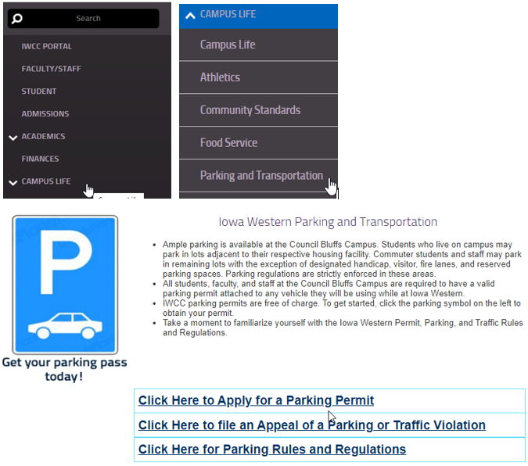

Safety and Security
Iowa Western Campus Security has officers available 24/7. Campus Security responds to all types of public safety emergencies as well as escort individuals who may feel uncomfortable walking or riding alone. Our officers are committed to:
- Responding to campus emergencies
- Escorting students who are uncomfortable being alone to and from their vehicle

In the case of an emergency requiring a rescue response;
- Call 911
- Report Emergency to Campus Security
  - Text or Call: 402-659-4939
  - or 8000 from any campus phone

Reiver Alert System
Reiver Alert (WENS – Wireless Emergency Notification System) is to be used principally for events that are deemed to be true emergencies but will also provide information about weather-related class cancellations or closings. Alerts are sent either by text message or email notification, or both. To receive text message alerts regarding campus emergencies please click this link: Iowa Western Community College WENS (inspironlogistics.com)
You can also sign up through ROC by going to the MENU, click on COLLEGE SERVICES, then REIVER ALERT.
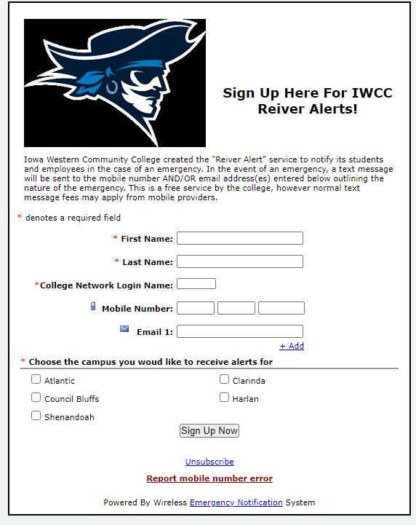

Standard Response Protocol

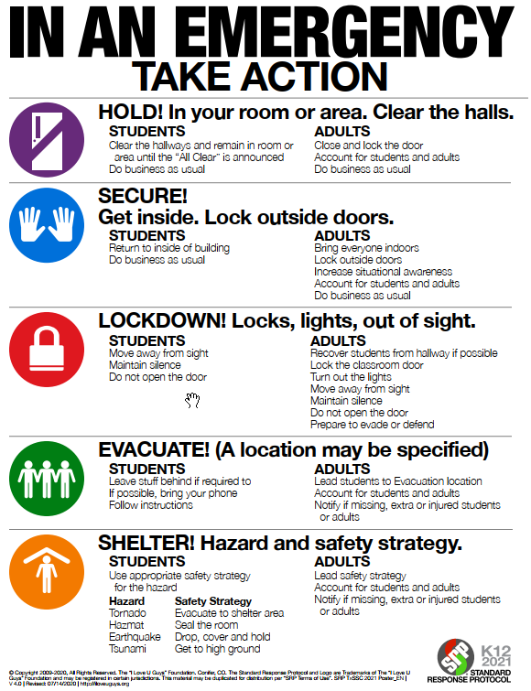

Academics

COURSE SYLLABUS
The course syllabus is an important tool for communication and interaction between the instructor and students. It serves as a source of information and a course road map for students, and it relays expectations and intentions regarding the course. The syllabus includes the course content, structure, materials and strategies that the instructor plans to use to promote learning. It answers several questions for the students:
- What is the rationale for the course?
- When and where does the class meet?
- What should the student be able to learn and do as a result of completing this course?
- How will the student’s learning be assessed?

The syllabus serves as an agreement or contract between the instructor and student by outlining the scope and sequence of the course and student expectations in order to successfully complete the course. The syllabus provides multiple functions for students including;
- Helping set the tone for the course
- Outlining the course logistics
- Defining student responsibility for course work
- Describing levels of learning from passive (memorization and recall) to active (problem solving and critical thinking)
- Helping students assess his/her readiness for the course
- Describing available learning resources
- Communicating the role of technology in the course
- Identifying course assignments, deadlines, test dates, and homework, etc.

ATTENDANCE
Attendance will be taken and recorded at every class meeting. Instructors are responsible for developing and implementing their own system and forms for recording class attendance which may be checked and verified by sources from both on and off campus. These include, but are not limited to, IWCC Student Services Personnel, the Veterans Administration, federal, state, county and private human services agencies, and scholarship granting organizations. This policy is subject to the limitations of The Family Educational Rights and Privacy Act. IWCC faculty members endorse the research that there is a strong correlation between student learning and student attendance and participation in class.

FINAL EXAMINATIONS
All courses offered within academic programs of study at Iowa Western Community College shall meet certain criteria as stated in Chapter 21 of the Iowa Legislative Code. These criteria are minimal requirements that establish standards for instructional practices. In conjunction with these requirements, instructional methodology (classroom work, laboratory work, clinical practice or work experience) and credit hour determinations have been outlined. Each type of instructional methodology shall include culminating activities as applicable. These activities shall be above and beyond the minimal instructional requirements for the course. Such activities are planned by the instructor as appropriate to the methodology and course objectives and may include the following:
- Written final examinations
- Oral final examinations
- Skill performance examinations
- Other structured activities supplemental to the instructional process

The final exam weeks planned during the academic terms at Iowa Western Community College allow instructors to schedule and conduct appropriate activities within the parameters of their courses. Final exam information should be included in the syllabus provided on the first day of class. For further assistance with any questions or concerns, please contact the instructor.

ACADEMIC STANDARDS
It is the policy of Iowa Western Community College to promote academic progress for each individual student. To encourage each student to strive for the highest academic achievement of which he or she is capable, the following policy has been adopted:

A student who has attempted six or more semester hours of academic credit is required to maintain a cumulative minimum grade point average of 2.0. A student who fails to maintain this average will not be in “Good Academic Standing” at the College for the following semester. If the grade point is not at least 2.0 at the conclusion of the following semester, the student may be placed on academic suspension. A student who earns at least 2.0 GPA for an academic semester may avoid suspension even though he or she is not in “Good Academic Standing” until the cumulative GPA reaches 2.0.

A student who is academically suspended from the College may not re-enroll in Iowa Western
Community College unless he or she has written permission from the Vice President of Academic Affairs. This policy is independent of Financial Aid Satisfactory Academic Progress Criteria.

PROBLEM RESOLUTION
Students with concerns about the course, instruction, or grades are advised to discuss those concerns with the instructor. If this does not resolve the issue, the student should contact the appropriate Dean. Students can find the Dean contact information in the course syllabus.

GRIEVANCE PROCESS FOR STUDENTS
Academic Grievance An academic grievance is defined as a written statement, signed by the student, expressing a complaint, resentment, or accusation about an academic circumstance which is thought by the student to be unfair. Any academic grievance that initiates an investigation will have the outcome determined based off of the Preponderance of Evidence Rule, which indicates that the College personnel determining the outcome must be 51% positive that their decision is correct and justified.
A grievance shall not include any matter which would infringe upon the principles of academic freedom as exercised by the professional staff and faculty members. This includes the selection and presentation of classroom or laboratory subjects and the determination of grades in all college courses. A grievance shall also not include any matter of a criminal nature or any matter which is subject to the Student Code of Conduct, Discipline and Appeals Procedures.

- The student should initially try to resolve the grievance within the instructional department, by first talking with the instructor and then the Dean.
- The Dean or the student may wish to consult or seek assistance from an advisor or faculty member prior to discussing the grievance with the Vice President of Academic Affairs.
- If the grievance cannot be resolved within the instructional division the student should talk with the Vice President of Academic Affairs. The Vice President of Academic Affairs, will try to resolve the grievance with assistance from other personnel as needed.

The decision of the Vice President of Academic Affairs will be final and ends the grievance process.

IOWA WESTERN CODE OF CONDUCT
Students are expected to comply with all Board, Administrative and Faculty policies on the College campus, and at all activities, functions and events sponsored or supervised by the College. Conduct which is contrary to any of the following may subject the student to disciplinary action and shall constitute a violation. Students who allegedly violate the Code will be found responsible or not responsible for their actions based off of the Preponderance of Evidence Rule, which indicates that the College personnel determining the outcome must be 51% positive that their decision is correct and justified. See full violation descriptions here.

Violations of the Code include but are not limited to:

- Academic Dishonesty- Plagiarism, Cheating, Misrepresentation
- Discrimination and/or Harassment
- General Harassment
- Possession, Use, Manufacturing, Distribution or in the Presence of Alcohol, Drugs, Synthetic Substances and other Controlled Substances on Campus
- Dangerous Conduct
- Misuse of College Property
- Use or Possession of a weapon, fireworks or explosives
- Threatening Behavior
- Non-Compliance with College Personnel
- Disruption of the Educational Process
- Traffic and Parking
- Disturbing the Peace
- Misrepresentation
- Housing violations
- Cafeteria/Galley Violations
- Retaliation
- Sexual Harassment
- Unlawful Acts
- Computer Misuse Policy

Iowa Western Resources

ACADEMIC SUPPORT CENTER / TUTORING
The Academic Support Center (ASC) is located next to the Cyber-Library on the 2nd floor of the Student Center and offers free academic assistance in a variety of “core” subjects, specializing in assistance for math and writing classes. Peer Tutors are academically successful students trained to assist other students with many of the general requirement courses necessary for most associate’s degrees. Peer tutors maintain regular hours and are available on a walk-in basis. Group tutoring is also available, but must be scheduled in advance. For more information about the free tutoring available to all IWCC students, contact the Academic Support Center at (712) 388-6841 or email Tutoring@iwcc.edu.

COUNSELING/PERSONAL ADVISING
The Student Support and Outreach Department provides inquiring IWCC students with information, resources, and short-term crisis interventions or advising in order for them to become better equipped to deal with personal problems that may impact their academic progress. Students are urged to seek such help before personal problems, including mental health issues, family/roommate conflicts, or academic struggles, seriously damage their academic performance or future quality of life. For more information, contact the Director of Student Support and Outreach at (712) 329-4750 or email StudentOutreach@iwcc.edu.

DISABILITY SERVICES
In accordance with the Americans with Disabilities Act (ADA), Iowa Western Community College provides reasonable accommodations to students with documented disabilities. Students who need accommodations arranged must provide disability documentation to the Disability Services Coordinator along with scheduling a meeting to arrange such accommodations. Students are strongly encouraged to provide documentation of their disability and decide early in their semester registration process in order to receive timely services. Disability Documentation includes a diagnosis of a specific disability, states how the disability limits a major life activity, explains how the disability affects the student’s academic performance, and suggests educational accommodations appropriate to a college setting. All disability documentation files are kept strictly confidential with the Student Success Office. For more information, contact the Disability Services Coordinator at (712) 325-3299 or email DisabilityServices@iwcc.edu.

Iowa Western Policies
CAMPUS SAFETY & SECURITY

CAMPUS SECURITY AND LAW ENFORCEMENT
The Council Bluffs campus of Iowa Western Community College contracts campus security with a private security firm and provides staff 24 hours a day, 7 days a week. Campus Safety and Security officers do not carry weapons or have arrest authority. IWCC safety and security officers have the authority to ask for identification and to determine whether individuals have lawful business at IWCC. Safety and security officers have the authority to issue traffic and parking tickets, which are billed to financial accounts of students, faculty, and staff. Campus Safety and Security can be reached at (402) 659-4939 and is text message enabled.
Off-duty Council Bluffs Police Officers are hired to work evening and early morning hours in Residence Life are contracted for other special campus events and activities. Council Bluffs Police Officers are in uniform, have jurisdiction on campus, carry weapons, and have arrest authority. IWCC maintains a highly professional working relationship with the Council Bluffs Police Department, Pottawattamie County Sheriff’s Office, and all other local, state, and federal law enforcement agencies. All crime victims and witnesses are strongly encouraged to immediately report the crime to the appropriate Police agency.

GENERAL PROCEDURES FOR REPORTING A CRIME OR EMERGENCY
All students and staff should report any incidence of crime to IWCC Safety and Security staff, as well as your appropriate on campus housing personnel. To report a crime: Contact Campus Safety and Security at (402) 659-
4939 to report a non-emergency or call 911 for emergencies. The Campus Safety and Security cell phone (402) 659-4939 does have text messaging capability for students who need this feature to report a crime or emergency. You can call 8000 from any campus phone and reach security as well. In addition, you may report a crime to the following areas:

Council Bluffs Campus
Director of Campus Safety and Security (712) 325-3727, Fremont Hall Security Room
Director of Student Conduct & Intervention (712) 325-3728, Ashley Hall 173
Director of Residence Life (712) 325-3487, Reiver Suites II
Residence Life Coordinator - Reiver Suites I (712) 256-6526, Reiver Suites I
Residence Life Coordinator – Reiver Suites II (712) 325-3445, Reiver Suites II
Residence Life Coordinator - Reiver Tower& Village (712) 388-6862, Reiver Tower
All Other IWCC sites – Center Director

TIMELY WARNINGS
In the event that a situation arises that, in the judgment of campus administrators, constitutes an ongoing or continuing threat, a campus wide “timely warning” will be issued. The warning will be issued through the college email and online system to students, faculty, and staff. Depending on the particular circumstances of the crime and especially in situations that could pose an immediate threat to the community or individuals, a notice may be sent via the college “Reiver Alert” system, placed on the campus-wide television monitor system, and notices may be posted in campus facilities.

CAMPUS EMERGENCIES
In the case of an emergency requiring rescue response, please call 911. All campus emergencies should also be reported to Campus Security by calling (402) 659-4939 or 8000 from any campus phone. The Campus Security cell phone (402) 659-4939 does have text messaging capability for students who need this feature to report a crime or emergency. Reporting an emergency to campus security will ensure that emergency responders will be directed to the correct location when they arrive on campus. Emergencies that occur in Residence Life should be reported to Residence Life staff by contacting the appropriate facility front desk:
Reiver Suites I: (712) 388-7696
Reiver Suites II: (712) 388-7695
Reiver Tower and Reiver Village: (712) 325-3444

Students will be notified of emergencies like tornados or fire by campus-wide alarm sirens. Other emergencies affecting students may be communicated through campus television monitors or bulletin board postings, or through communication from faculty, staff, or Residence Life personnel.

EVACUATION PROCEDURES FOR STUDENTS WITH DISABILITIES
In case of emergency situations, we encourage students who might need assistance to identify and discuss, in advance, a plan of action with someone who might assist them in leaving the building and/or who will inform emergency personnel/campus security of their presence and where they are located so that further assistance can be provided.
All students with physical mobility limitations should prepare for an emergency ahead of time by instructing faculty and classmates on how to assist in an emergency. Instructors who have students in their classes who might have problems leaving the building during emergencies should discuss procedures ahead of time.
Hearing or visually impaired persons working alone in isolated areas such as study rooms and labs should notify nearby building staff of their location. For more information, email DisabilityServices@iwcc.edu or call (712) 3253299.

VIDEO SURVEILLANCE
The College utilizes video surveillance systems to enhance the safety and security of students, employees, visitors, and property. The college will protect the reasonable expectation of privacy of the campus community, as defined by law, in its use of video surveillance systems. The primary use of video surveillance systems will be to record information that may be useful to college administrators in the event of a criminal act, property damage, or serious violation of campus policy. Video surveillance systems are not a guarantee of safety and security but are a tool to assist Campus Safety and Security, as well as college administrators, in their efforts to provide a safe and secure environment. Video surveillance also serves as a deterrent to property-related crime and provides real-time information during emergencies. The utilization of surveillance cameras is part of an integrated security approach that includes a number of strategies, including physical presence of security officers, access controls, and alarms.

MONITORING AND ACCESSING VIDEO SURVEILLANCE RECORDINGS
Video surveillance shall be used exclusively for purposes of campus safety and asset protection. Real- time monitoring will be limited to situations where an emergency requires the use of the system to gather needed information, when a threat to campus security or property has been received by campus officials, or when Campus Safety and Security staff determines there is a need to scan campus property in lieu of vehicular or foot patrol. Maintaining confidentiality and securing the privacy of campus community members and visitors is foremost in our practice. Therefore, only a limited number of staff members have access and authority to access, monitor, view, and make copies of footage. Such authority will be granted to employees by Cabinet.
Recordings shall be viewed exclusively for the purpose of investigation of crime or serious campus policy violations and adjudication. Staff members must report all observed policy violations, misconduct, and potential criminal acts to Student Life and Student Success for investigation, adjudication, and inclusion in the Campus Crime Log. Video surveillance shall not be used to track any member of the campus community unless a threat to campus security has been received by college officials, or reasonable cause exists that a serious violation of campus policy or that a criminal act has been committed.

RELEASE OF VIDEO SURVEILLANCE RECORDINGS
Only authorized staff members may access and monitor video surveillance; however, occasions may arise when circumstances demand that other staff members have a legitimate need to view recorded data. Such staff members will be permitted to view footage only with the prior approval of the Director of Safety and Security and a college vice president. Circumstances that may warrant a review of footage shall be limited to instances where an incident has been reported or observed, or for investigation of a potential crime. A request to review recorded footage must be submitted and approved in writing.
Requests from any college employee to obtain a copy of recorded data must be authorized by the Director of Campus Safety and Security and a college vice president. All external requests for the release of recorded data must also be submitted to the Director of Campus Safety and Security for approval prior to release. Recorded data may be released when it is related to a criminal investigation, civil suit, subpoena or court order, arrest, or to disciplinary proceedings against a student or personnel actions against an employee.

SECURITY AND RETENTION OF VIDEO SURVEILLANCE RECORDINGS
Video recordings will be stored and transported in a manner that provides security. All recordings shall be kept in a secure location. Recordings not related to or used for investigative purposes shall be kept confidential and destroyed regularly in accordance with prevailing records retention law. All recordings used for an investigation or prosecution will be retained until the end of the proceeding and appeal period unless directed otherwise by the civil court or senior campus administrator.

CIVIL RIGHTS ACT
The Iowa Western Community College (Merged Area XIII) filed assurance of compliance with Title VI of the Civil Rights Act of 1964 on September 9, 1966, and accepts all requirements imposed by or pursuant to the regulation. No person in the United States shall, on the ground of race, sex, color, creed or national origin, be excluded from participation in, be denied the benefits of, or be otherwise subjected to discrimination under any program or activity offered by the College. Iowa Western Community College adheres to the principle of equal education and employment opportunity without regard to race, color, creed, religion, national or ethnic origin, ancestry, genetic information, physical or mental disability, age, sex, sexual orientation, gender identity or expression, pregnancy, marital status, veteran status, AIDS/HIV status, citizenship, or medical condition, as those terms are defined under applicable laws.

EQUAL OPPORTUNITY AND NON-DISCRIMINATION POLICY
It is the policy of Iowa Western Community College to provide equal educational opportunities and not to discriminate on the basis of race, color, creed, religion, national or ethnic origin, ancestry, genetic information, physical or mental disability, age, sex, sexual orientation, gender identity or expression, pregnancy, marital status, veteran status, AIDS/HIV status, citizenship, or medical condition, as those terms are defined under applicable laws, in its educational programs, activities, or employment practices.
Questions or complaints? Contact Title IX and Equal Opportunity Coordinator, Kim Henry, or ADA Coordinator, Keri
Zimmer, equity@iwcc.edu, 712-325-3200, or the Director of the Office for Civil Rights, U.S. Department of Education, Citigroup Center, 500 W. Madison, Suite 1475, Chicago, IL 60661, (312)-730-1560, OCR.Chicago@ed.gov. More information at https://www.iwcc.edu/about/statement.asp.

TITLE IX
It is the policy of Iowa Western Community College to comply with Title IX of the Education Amendments of 1972, which prohibits discrimination (including sexual harassment and sexual violence) based on sex in the College's educational programs and activities. Title IX also prohibits retaliation for asserting or otherwise participating in claims of sex discrimination. Iowa Western Community College has designated a Title IX Coordinator, to coordinate IWCC's compliance with and response to inquiries concerning Title IX. For more information on Title IX and sex and gender based discrimination, please refer to the Student Code of Conduct, Disciplinary and Appeal Procedures, Section D, Sexual Misconduct Policies and Procedures.

PREGNANT AND PARENTING STUDENT STATEMENT
Iowa Western Community College does not discriminate against pregnant and parenting students based on pregnancy, childbirth, false pregnancy, termination of pregnancy, or recovery from any of these conditions in accordance with Title IX regulations. The Title IX regulation also prohibits the College from applying any policy related to a student’s parental, family, or marital status that treats students differently based on their sex. In addition, Title IX prohibits the exclusion of a pregnant student from participating in any part of an educational program, including extracurricular activities, opportunities for student leadership, and other activities.

AMERICANS WITH DISABILITIES ACT AND THE REHABILITATION ACT
The Americans with Disabilities Act (ADA), Public Law 101-336, was enacted on July 26, 1990, to provide a clear and comprehensive mandate for the elimination of discrimination against individuals with disabilities. This federal legislation requires equal treatment of people with disabilities in employment, public services and transportation, public accommodations, and telecommunication services. Section 504 of the Rehabilitation Act of 1973, with virtually identical purposes, applies to any college or university that receives federal funds in any program.
Iowa Western Community College, a public entity as set forth in Title II of the ADA, is subject to the requirements of the Americans with Disabilities Act. Title II of the ADA prohibits discrimination against qualified individuals with disabilities with regard to the services, programs, and activities at Iowa Western Community College. Iowa Western Community College is also prohibited from discrimination against individuals with disabilities in its employment practices pursuant to Title I of the Americans with Disabilities Act.

For more information, contact the Coordinator of Disability Services located in the Student Center 2nd Floor, or call (712) 325-3299.

FERPA
The federal Family Education Rights and Privacy Act of 1974 (FERPA) prohibits Iowa Western from releasing protected information on current or former students to external third parties for purposes of solicitation without students’ written permission. No exceptions to these prohibitions are permissible pursuant to this policy statement. Iowa Western is permitted to disclose, without consent, information considered to be “directory” information. In effort to protect the privacy of current and former students, Iowa Western typically does not honor their party requests for “directory” information, even though the college is permitted to do so, unless the release information is required by law, court order or through data-sharing agreements. The following information is considered to be directory information:

- Student’s name
- Telephone number
- Major field of study
- Participation in officially recognized activities
- Athletic team member’s weight and height

- Dates of attendance
- Degrees
- Awards received
- Most recent previous educational institution attended
- Enrollment status (full-time, part-time, or not enrolled)

