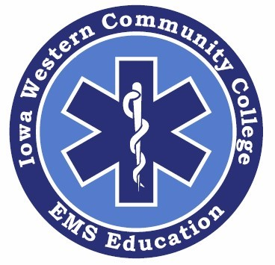

Student Health History Record
Emergency Medical Services Program

Please Put Your Program Name Here (EMR, EMT, AEMT, or Paramedic)

Please PRINT Your Name Here

*Disclaimer: The health history and physical of any student IS NOT used as criteria for acceptance into any Iowa Western Community College Emergency Medical Services Program. The Information contained within this health and immunization record is kept strictly confidential. Once completed, this record will be placed in the student’s personal folder.

*Please review this form prior to your appointment with your healthcare provider.

Iowa Western Community College EMS Education Health History

Student Information

Name: _____________________________________ Date of Birth: ______/______/__________

Emergency Contact Information

Name: _______________________________________________ Phone #: _________________________

Medical History

Prior to your exam, please answer all questions. Comment on all “yes” answers, including year of occurrence.

Have you had / or currently have? | Y | N | Comments
Heart Disease (High Blood Pressure)
Diabetes
Respiratory Disorder (Asthma, TB)
Ear, Nose, Throat Problems
Psychological or Emotional Disorder
Convulsive / Seizure Disorder
Hepatitis, Liver Disease
Disease or Injury of Joints
Back Problems OR History of Back Problems
Has your physical activity every been restricted? (Give reason / duration)
Do you have any physical limitations that restrict activity and / or require special consideration(s)?
Have you had any serious illness or injury, or been hospitalized other than already noted?
Do you have or are you a carrier of any infectious disease which pose a health or safety risk to you or others? (If yes, explain and provide statement from your healthcare provider under which conditions you can’t participate)
Do you have any condition that would restrict activity and / or require special adaptation(s)?
Are you currently being treated by a healthcare professional for any condition(s)?
Are you taking any medications regularly or as needed? (Other than Aspirin, Ibuprofen, or Tylenol)
Allergies / Sensitivities (latex, medications, environmental, food)

*If there is a change in this information, I will notify my instructor.

Student Signature: ______________________________________________ Date: ___________________________

Iowa Western Community College EMS Education Physical Exam

Student Information

Student Name: _____________________________________________ Program: ______________________________

To be completed by a physician, nurse practitioner, or physician assistant. The physical exam must not be older than one (1) year prior to the start of the program.

Vitals: T: _______ HR: _______ RR: _______ B/P: ______/______ HT: ______/______” WT: _______ lbs.

Vision: R 20/_______ L 20/_______ Corrected: Y_______ N_______

Clinical Evaluation | Within Normal Limits  (WNL) | Comments
General Appearance

HEENT

Neck / Thyroid (ROM)

Lungs / Chest

Cardiovascular

Abdominal / GU / Hernia

Back / Spine (ROM, Tenderness) |  | Lifting Restrictions? Yes ______ or No _____
Psych

Neurologic

Other Findings

If health conditions are present, do they create a limitation in the ability to provide healthcare? Yes _____ or No _____
If Yes; Please Explain _______________________________________________________________________________

Does the student’s examination reveal any active illness that would be a hazard to others? Yes _____ or No _____
If Yes; Please Explain _______________________________________________________________________________

Based on today’s exam and the disclosed health history, this student does not have any health conditions that would create a hazard to self and others or limit their ability to provide healthcare. In addition, this student is capable of performing the physical requirements of his or her program, which includes but is not limited to bending, stooping, pushing, and lifting without weight restriction.

Agency or Clinic Name

Printed Name | Title
Signature | Date of Exam

